Homework Assignment Week 3
Objective:
- Be able to write a Boolean expression using relational operators
- Be able to conditionally execute the code using if-elif-else statements
- Be able to use logical operators and write multiple conditions

Instructions:
- Name your python file as HW_W3_{yourFirstName}{LastNameInitial}.py
For example: Michael K will name the python file of homework assignment Week 3 as HW_W3_MichaelK.py
- Write the Python code for either Problem 1 or Problem 2
- The code should only use Python commands that have been covered in the course up to this point.
- You will record a small video (3-5 min) to explain the code you wrote for the assignment. For learning how to create a recording in Zoom, refer to document ‘How to record video presentation using Zoom’ in D2L Content -> How-To Guides
- Submit both, .py file and the video, in D2L Assignments -> Chapter 3 HW Dropbox. Refer to the document ‘How to submit homework assignment with video presentation’ in in D2L Content -> How-To Guides.

Grading Rubric:

Detailed rubric for the assignment is given in the D2L Assignments -> Homework Assignment Week 3

15 points are assigned for the Python file submitted

10 points are assigned for the video presentation

Problem 1: Write a program that asks the user to enter a person’s age. The program should display a message indicating whether the person is an infant, a child, a teenager, or an adult. The following are the guidelines:
- If the person’s age is negative, then print that the age is invalid.
- If the person is 1 year old or less, he or she is an infant
- If the person is older than 1 year, but younger than 13 years, he or she is a child
- If the person is at least 13 years old, but less than 20 years old, he or she is a teenager
- If the person is at least 20 years old, he or she is an adult
Expected Output:
Test Case 1:
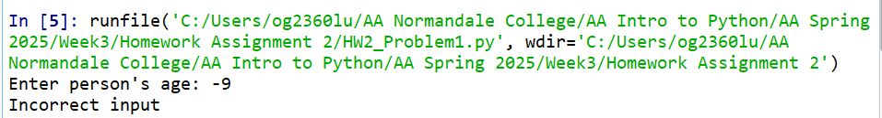
Test Case 2:
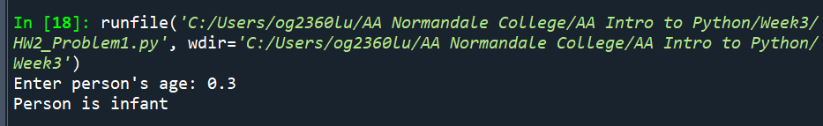
Test Case 3:
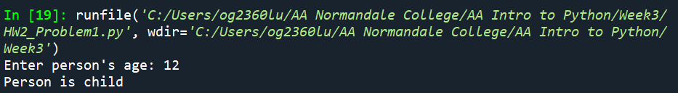
Test Case 4:
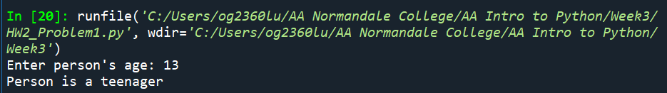
Test Case 5:
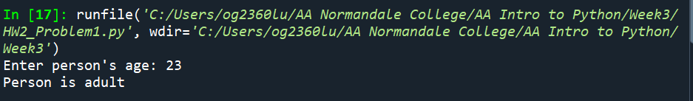
Problem2: Write a program that asks the user to enter the number of seconds and works as follows:
- If number of seconds are negative then the program should display that input is invalid.
- There are 60 seconds in a minute. If the number of seconds entered by user is less than 60, the program should display the number of seconds as it is.
- If the number of seconds entered by user is greater than or equal to 60, the program should convert the number of seconds into minutes and seconds
- There are 3600 seconds in an hour. If the number of seconds entered by user is greater than or equal to 3600, the program should convert the number of seconds to hours, minutes and seconds
- There are 86400 seconds in a day. If the number of seconds entered by user is greater than or equal to 86400, the program should convert the number of seconds to days, hours, minutes and seconds.

Expected Output:
Test Case 1:
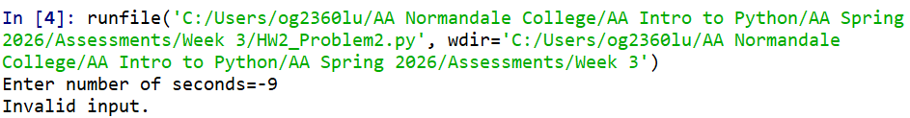
Test Case 2:
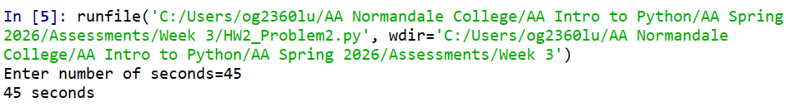Test Case 3:
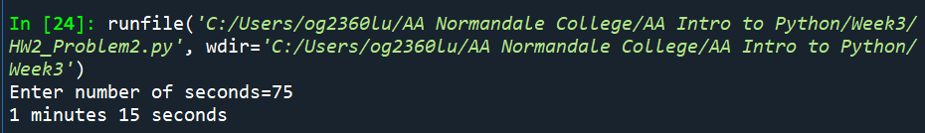
Test Case 4:
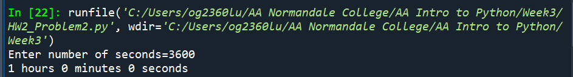
Test Case 5:
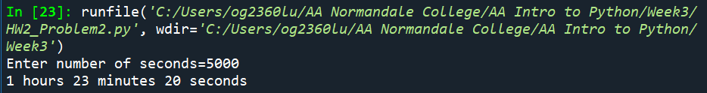
Test Case 6:
